Fault-Tolerant Routing Strategy Using Routing Capability in Hypercube Multicomputers

Ge-Ming Chiu and Kai-Shung Chen
International Conference on Parallel and Distributed Systems,
pp. 396-403, June 1996

Routing Capability or Safety vector (for faulty node) :
u_{k}= 1 ,1≦k≦n, if u is faulty node.
u₁= 0 , o.w.
u_{k}= 0 , if 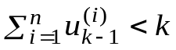
=1 , o.w.

To consider more than Safety vector:
1. Additional informaion in routing capability
Theory: The Hamming distance between source and destination is k.
If there is a neighbor of the source is (k+r)-capable, r is odd number and k+r≦n, then ROUTE routes the message through a path of length no greater than k+r+1.

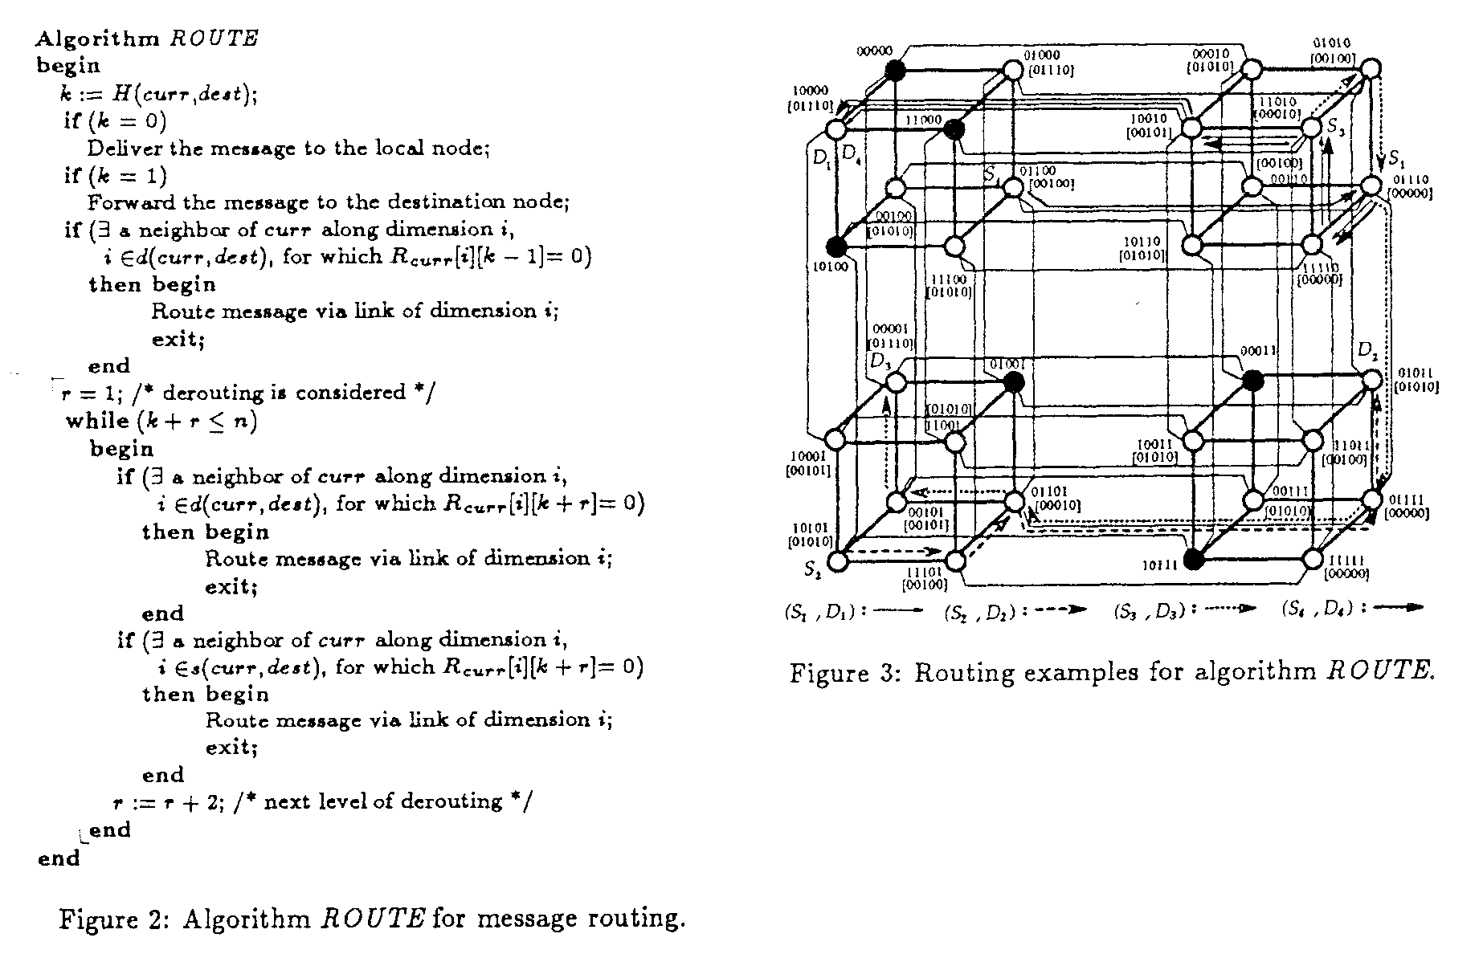
2. Directed routing capability
Undirected: S is not k-capable if there are more than or equal to k
non-(k-1)-capable neighbors
=>
Directed: If S has exactly k non-(k-1)-capable nighbors, then S is treated
as k-capable by those k non-(k-1)-capable neighbors, and
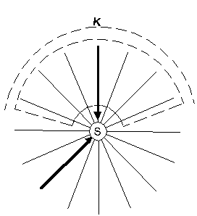
as non-k-capable by other neighbors.

Size | 8-cube |  | 9-cube
Faulty nodes | Undirected | Directed | Undirected | Directed
8 | 9.3 | 7.9 | 4.7 | 4.4
12 | 43.2 | 26.6 | 15.6 | 12.5
16 | 167.8 | 76.5 | 47.3 | 29.3
20 | 542.1 | 208.6 | 128.5 | 62.1
24 | 1501.4 | 548.2 | 326.3 | 128.1
28 | 3534.0 | 1397.0 | 780.6 | 261.9
Average numbers of source-destination pairs for which no shortest paths are indicated.
For each number of faulty nodes, 5000 faulty patters are randomly selected.

Created by : Seng-I Yeh

Date : Nov. 19 , 1999

